**HTML Practical Test**

**J2EE**

**Cogent Ltd.**

**Duration: 30 Minutes**

**Date: 09/02/2019**

1. **Create table**
   1. 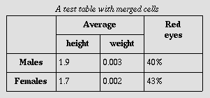
2. **Create Form**
   1. 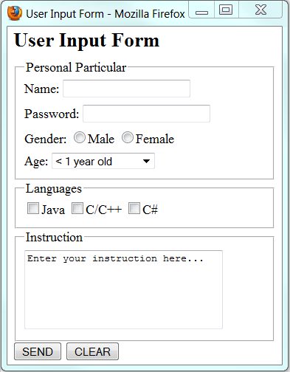
3. **Create Order & Unorder List**
   1. 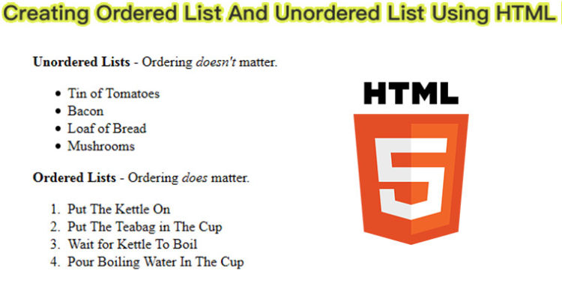
4. **Create Iframe**